**Unit - 5**

**Assignment**

1. Write down the steps to create a macro called basic_maths to perform maths functions like product, sum, average and standard deviation of an Array for the below data:

### 

1. Write down the steps to create a macro for formatting data as shown below:

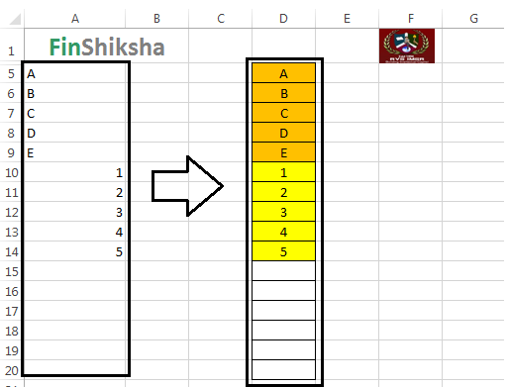

1. Write down the steps to create a macro called basic_math to perform maths functions like product, sum, average and standard deviation of an Array for the below data:



  